# CS 255 System Design Document Template

Gerardo Gonzalez

## UML Diagrams

### UML Use Case Diagram

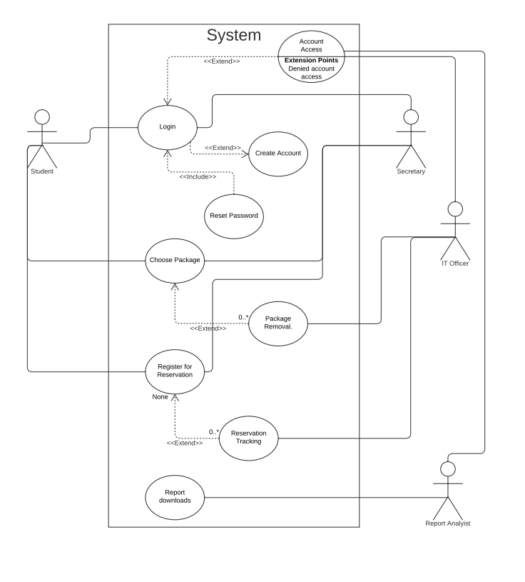

### UML Activity Diagrams

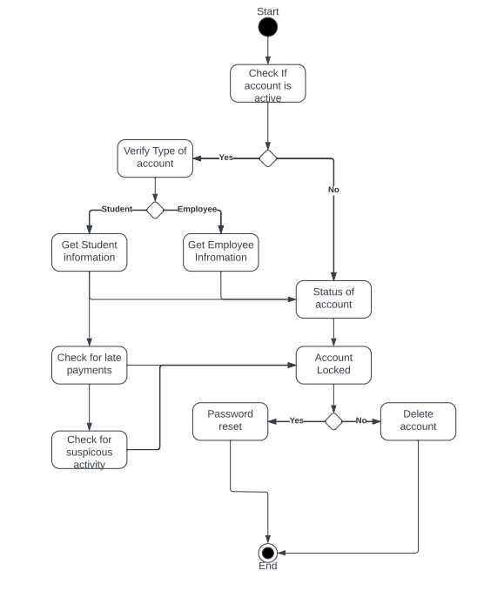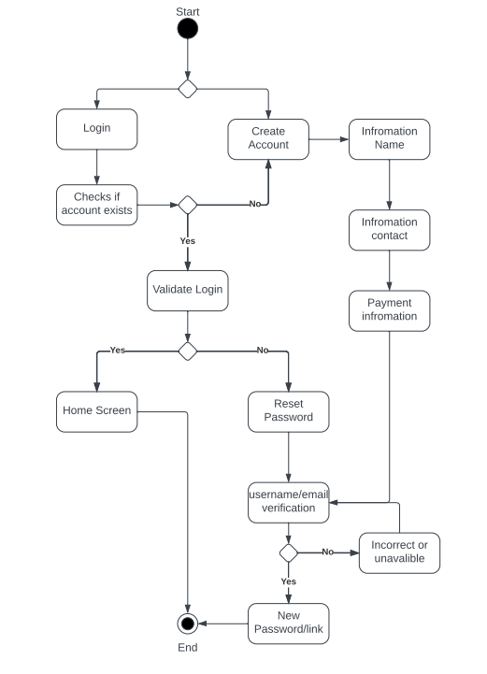

### UML Sequence Diagram

### UML Class Diagram

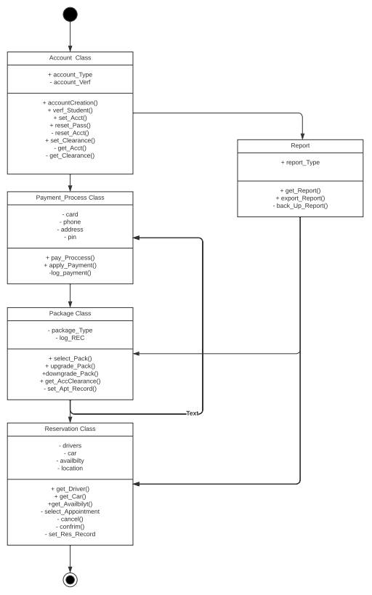

## Technical Requirements

Based on the requirements we have concluded that the system will need to perform both online and offline, in order for this to happen the system will need to run on the cloud that way DriverPass employees and management can focus on day-to-day business operations as requested.

Next, we would need to discuss the type of hardware needed, since the hardware is not on premises all that is needed is a computer with internet access for the employees to access the cloud. Students, they will need to have a device that has the capability to access the internet and also download for offline viewing, since the student wound downloads the content it’s important that the student also have storage space.

For the required software it will need to be accessed on all “Operating Systems” OS platforms such as mobile, Windows, MacOS, and Linux devices. This way it can meet the requirement for the system to run anywhere and on any device as specified by the DriverPass.

Tools needed for this would need to be from the cloud provider, these tools would be needed to be developed later on to expand the digital tools as mentioned during the interview, such as incorporating a feature for DriverPass to edit, remove, and add packages. Another digital tool would be the download reports tool which would log all the reservations and users who registered those reservations.

Then the infrastructure would need to use a specific type of cloud service which is “Platform as a Service” PaaS this way DriverPass Management and IT can control the application and the data in the system.